---------------------------------------------------------------------

-- LAB 08

--

-- Exercise 3

---------------------------------------------------------------------

USE TSQL;

GO

---------------------------------------------------------------------

-- Task 1

--

-- Write a SELECT statement to retrieve the contactname and fax columns from the Sales.Customers table. If there is a missing value in the fax column, return the value ‘No information’.

--

-- Write two solutions, one using the COALESCE function and the other using the ISNULL function.

--

-- Execute the written statement and compare the results that you got with the recommended result shown in the file 72 - Lab Exercise 3 - Task 1 Result.txt.

--

-- What is the difference between the ISNULL and COALESCE functions?

---------------------------------------------------------------------

--------------------------------------------------------------------

-- Detyre 1

--

-- Nxjerr kolonat contactname dhe fax nga tabela the Sales.Customers. Ne qoftese ka ndonje vlere qe mungon ne kolonen fax,

-- te ktheje vleren ‘No information’.

-- Shkruaj dy zgjidhje, nje duke perdorur funksionin COALESCE dhe tjetra duke perdorur funksionin ISNULL.

--

-- Ekzekuto veprimet e mesiperme dhe krahaso rezultatin qe ju moret me rezultatin e deshiruar te treguar ne dokumentin 72 - Lab Exercise 3 - Task 1 Result.txt.

--

--Cili eshte ndyshime midis funksioneve ISNULL and COALESCE?

---------------------------------------------------------------------

Select c.contactname ,Fax = (case when ISNULL((c.fax),'null')= 'null' then 'No_information' else c.fax end)

From Sales.Customers c

--------------------------------

Select c.contactname ,Fax = (case when COALESCE((c.fax),'NULL')= 'null' then 'No_information' else c.fax end)

From Sales.Customers c

Ndryshimi = Gjenerojne te njejtin rezultat por ISNULL(,) merr dy parametra ndersa

COALESCE(,,,,,……..,) merr n-paramtra dhe kthen variablin e pare jo-null që vlereson

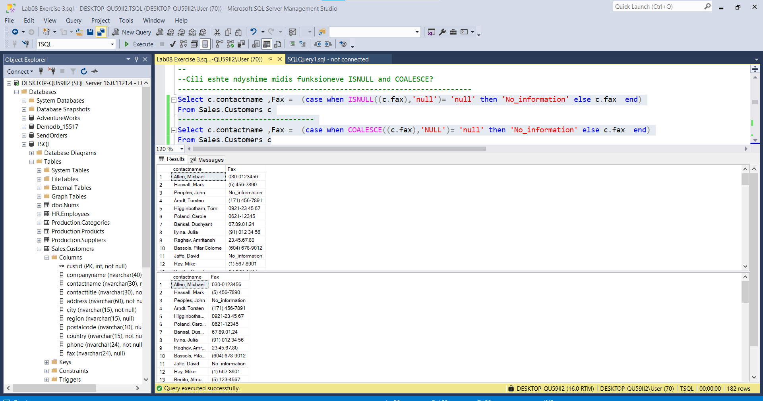

---------------------------------------------------------------------

-- Task 2

--

-- Update the provided T-SQL statement with a WHERE clause to filter the region column using the provided variable @region, which can have a value or a NULL. Test the solution using both provided variable declaration cases.

---------------------------------------------------------------------

---------------------------------------------------------------------

-- Detyre 2

--

-- Perditeso veprimet T-SQL me nje klause 'WHERE' duke perdorur variablin e ofruar @region,

-- e cila mund te kete nje vlere ose eshte NULL. Testo zgjidhjen duke perdorur te dyja variablat e ofruar ne deklarim.

---------------------------------------------------------------------

--DECLARE @region AS NVARCHAR(30) = NULL;

Select * From Sales.Customers

SELECT

custid, region

FROM Sales.Customers

Where isnull(Sales.Customers.region,'null')= 'null'

GO

-----------------------------------------------------------------------

--DECLARE @region AS NVARCHAR(30) = N'WA';

SELECT

custid, region

FROM Sales.Customers

Where isnull(Sales.Customers.region,'null')= N'WA'

GO

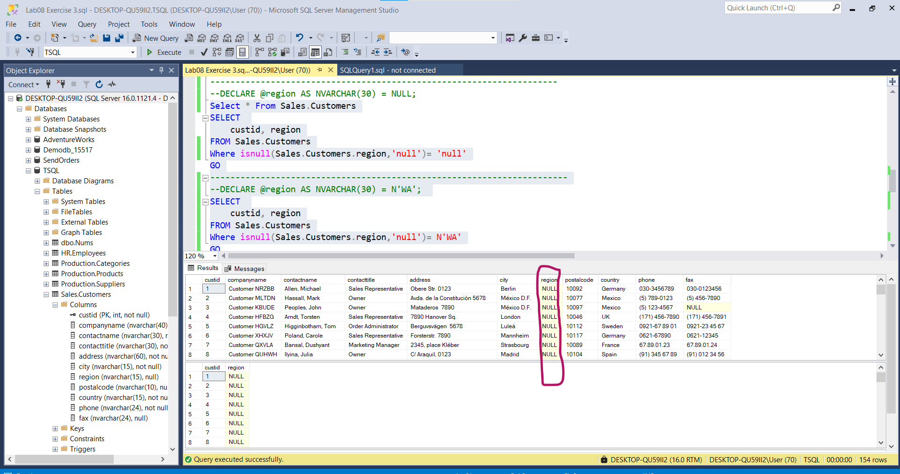

---------------------------------------------------------------------

-- Task 3

--

-- Write a SELECT statement to retrieve the contactname, city, and region columns from the Sales.Customers table.

-- Return only rows that do not have two characters in the region column, including those with an inapplicable region (where the region is NULL).

-- Execute the written statement and compare the results that you got with the recommended result shown in the file 73 - Lab Exercise 3 - Task 3 Result.txt. Notice the number of rows returned.

---------------------------------------------------------------------

--------------------------------------------------------------------

-- Detyre 3

-- Nxjerr kolonat contactname, city, dhe region nga tabela Sales.Customers.

-- Kthe vetem rrjeshtat qe nuk kane dy karaktere ne kolonen region, duke perfshire ato me nje region te papershtatshem(ku region eshte NULL).

-- Ekzekuto veprimet e mesiperme dhe krahaso rezultatin qe ju moret me rezultatin e deshiruar te treguar ne dokumentin 73 - Lab Exercise 3 - Task 3 Result.txt. Vere numrin e rrjeshtave qe u kthyen.

---------------------------------------------------------------------

Select c.contactname , c.region , c.city

From Sales.Customers c

Where not isnull(c.region,'null')='null'

